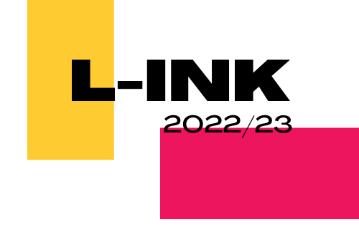
L-INK 2022/23 Application Form
To be filled out by parent or guardian of any applicants under 18.
Name of Parent/Guardian
Telephone No. Of Parent/Guardian
Email Address of Parent/Guardian
Home Address
Young Person’s Surname
Young Person’s Forename
Young Person’s Pronouns
Young Person’s Email Address
Young Person’s Mobile Number
Young Person’s Date of Birth
Travel Arrangements (How will your young person be getting here?)

About You (to be completed by the young person who is applying to L-INK)
Please use this space to tell us about yourself and why you are interested in joining L-INK. (No more than 500 words)

Medical Information (to be completed by parent/guardian if the young person is under 18 years old)
Does your young person have asthma, fits, faints, or any other allergies, illness or disability?
Does your young person have any accessibility requirements?
Is your young person allergic to any medicine/food/Elastoplast's, etc.?
Does your young person have any dietary requirements?
Name and Address of young person’s doctor
Is there anything else we should know?

Third Party Contact
As part of the Lindisfarne Gospels exhibition, we are working with the British Library and to evaluate the success of the learning programme we are using a trusted third-party evaluation firm, Spirul. Do you consent to your young person being contacted by Spirul via email to fill out an evaluation form about L-INK?

 | Yes |  | No

IMPORTANT INFORMATION to read before signing!
L-INK meet once each month, (unless stated). L-INK is a fixed-term project and we ask for a time commitment of one day (10:30am-4:00pm on the second Saturday of each month) per month plus one potential overnight trip to visit other galleries. We understand that participants have many extracurricular commitments and responsibilities as well as school/work, so if participants find that they are unable to commit to the project, please let us know so that we can offer places to others.

Signature
Parent / Guardian name (Print):________________________________________________

Signed:___________________________________________________________________

Date:____________________________________________________________________

Relationship to child:________________________________________________________

Emergency Contact telephone number(s):_______________________________________

Additional numbers to be contacted in an emergency
Name:__________________________________________________________________

Relationship to child:_______________________________________________________

Contact telephone number(s):_______________________________________________

Please return this form by 12:00pm 4th November 2022 to:
Dale Glenister
Email: dale.glenister@twmuseums.org.uk
Or via post to:
Dale Glenister
Young People’s Programmes Intern
Laing Art Gallery
New Bridge Street West
NE1 8AG

Adult and child consent form for photographic and film usage
Photographs will be taken during the L-INK project for documentation and marketing purposes. Please fill in this form to let us know your preferences.
This form must be completed before photography/video filming takes place.
Please read the 5 points below before signing this form.
1. I understand that Tyne & Wear Archives & Museums (TWAM) needs to take new photographs and video film (images) in order to promote its work and that it asks for volunteers to appear in publicity material for its projects and fundraising events.
2. I hereby grant TWAM permission to use the images of the adult and child named below and to make any reproductions or adaptations of the images for any purposes in relation to TWAM’s work including, without limitation, the right to use them in any advertisements and other publicity materials (leaflets, posters, publications), direct mail, books, presentations, newspapers, magazine articles, television programmes, social media, websites and internet publications.
3. I understand that it may be necessary for TWAM to share the images with its partner organisations to the extent it reasonably considers necessary for the purposes of the work and activities referred to above. We would like to share these images with [TWAM officer to insert names of organisations or delete point 3 if not applicable].
4. I understand that TWAM will keep all the images and use them for 3 years from the date of consent and delete them once they are no longer appropriate.
5. You can contact TWAM at any point and ask us not to use your photograph or film for any new purposes. If you ask us not to use the photograph or film in future we will comply with your request. Remember that once an article is published and in circulation (especially online) it may be copied and used by others.
6. You can read a full copy of our privacy notice on our website: www.twmuseums.org.uk/privacy-policy

Name:

Email address:

Telephone:

Being the parent of or person responsible for:
(1st child or young person’s name)

(2nd child or young person’s name)

I hereby agree: That my photograph / film and my child’s photograph / film or the photograph / film of the child or young person for whom I am responsible, can be used to promote TWAM and can be reproduced.
That my permission is given to use my photograph / film and my child’s photograph / film, on condition that my personal details and those of my child/children are not given to anyone unless I specifically give my permission in that regard. I understand that if I wish to withdraw permission for future use, I can contact TWAM at any time, although I understand that TWAM cannot withdraw images already published.

Signed:________________________________________________________________

Date: ____________________________

